**STEPS TO FOLLOW:**

<https://console.developers.google.com/cloud-resource-manager>

visit this link and create a new project (name as you wish).

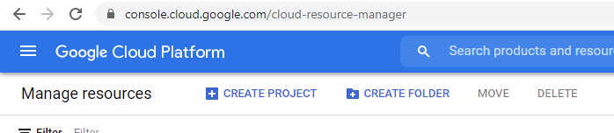

After that Select that project. (or click on the Google Cloud Platform)

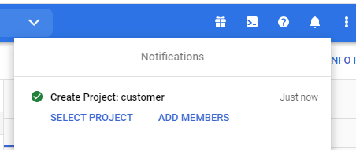

Now, scroll down the page and click on Explore and Enable APIs.

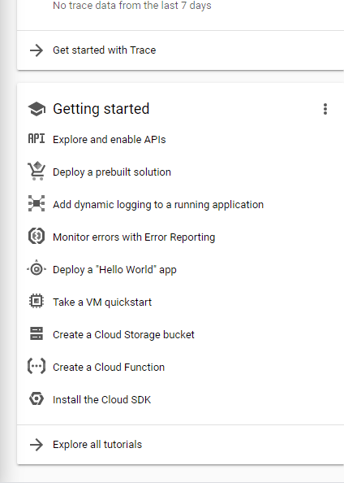

After that click on the + tab (+ ENABLE APIS AND SERVICES)

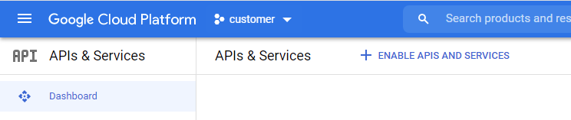

And search for GOOGLE DRIVE API.

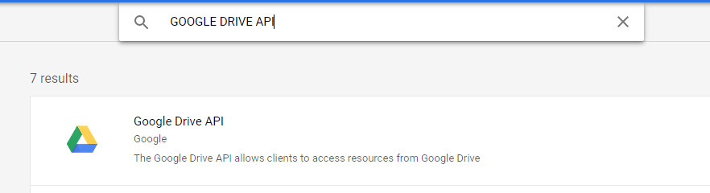

Click on that and Enable it.

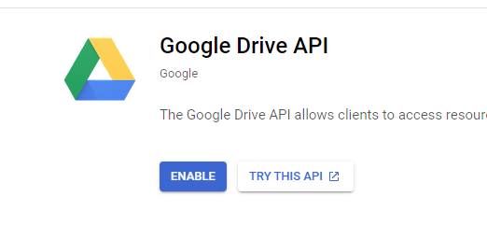

After Enabling that you’ll be moved to the Google drive API dashboard. Here you’ve to click on the Credentials.

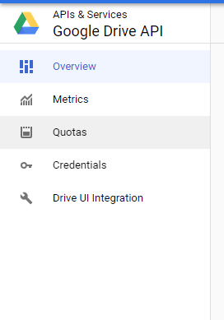

Again +CREATE CREDENTIALS and select the Service Account option.

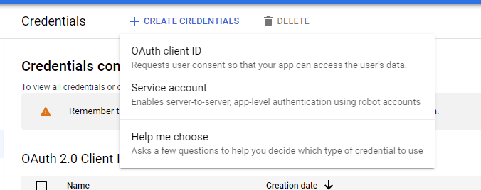

Now, provide any name as you want. (Ignore description)

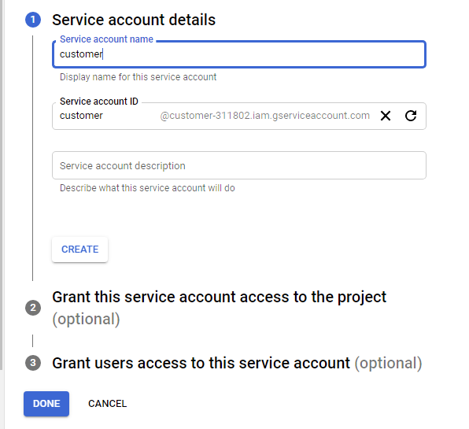

Done that move forward and grant access to owner or editor both will work fine.

Your service account is created.

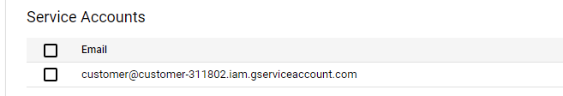

Now just click on the email and you’ll be moved to the following, click on KEYS.

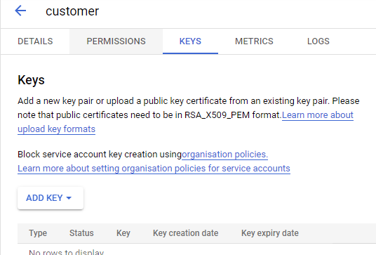

Click on ADD KEY. And then click on Create new key.

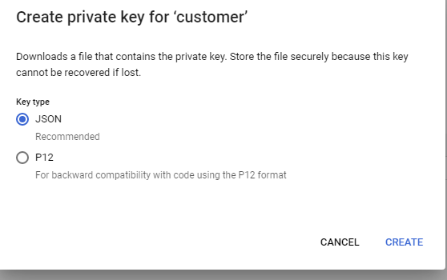

Select JSON format and simply CREATE. Your JSON file will be automatically starts downloading.

After that create your GOOGLE SHEET and name as you wish and SHARE that with the service account. By entering the email address which was generated above. Or you can get that email by opening the json file (copy the client_email).

**Now there will be total 3 files: python(.py) file which have the code, your .csv file and this JSON file.**

Before running this python file please install these two libraries using python terminal.

* pip install gspread
* pip install oauth2client